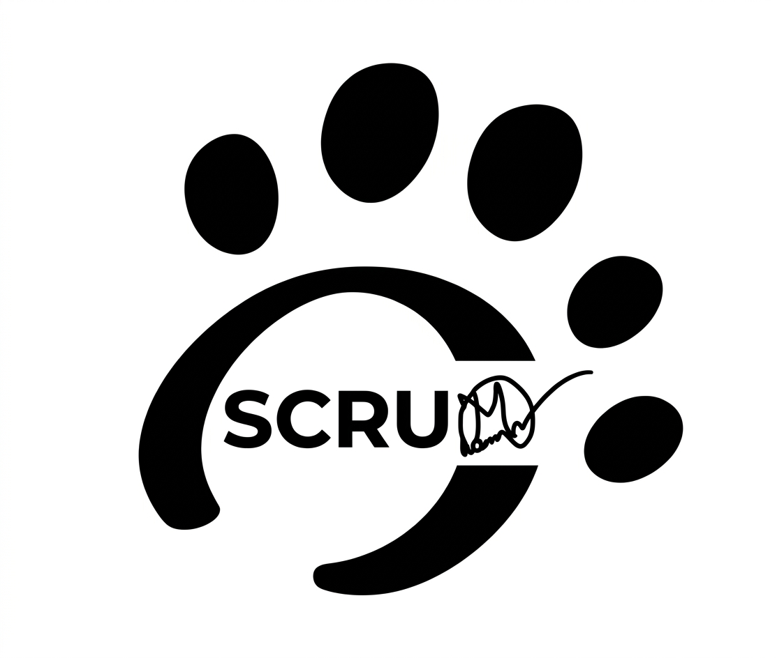
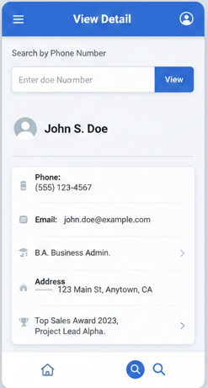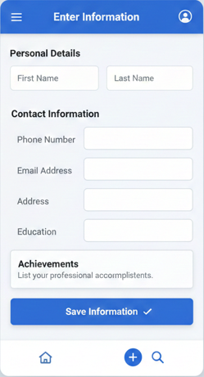
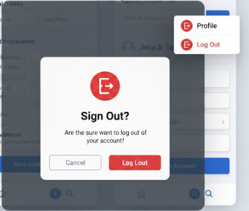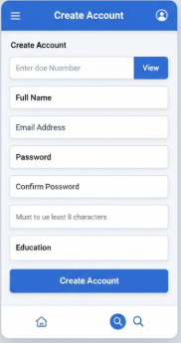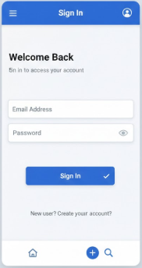

RTM & TM: https://docs.google.com/spreadsheets/d/1eog8Kl7WxBa4bFrhaL0Cx1JN-Z7-VFtq/edit?usp=sharing&ouid=113798593907109523647&rtpof=true&sd=true


So now tell me how to set my mind following Agail for SDLC and STLC for this above project

Perfect—this is the right question for a real Agile professional 👍
I’ll keep this practical, mindset-focused, and tied directly to your project screens.

How to set your mind to follow Agile for SDLC + STLC

(Using your User/Profile app project)

1️⃣ First: Reset your thinking (this is KEY)

❌ Old mindset

“First requirements → then dev → then testing”

✅ Agile mindset

“Design, dev, and testing happen together, repeatedly, in small pieces.”

You are not waiting for the full app.
You are delivering value every sprint.

2️⃣ Think in User Stories, not Screens (SDLC + STLC)

Don’t think:

“This is the View Profile screen”

Think:

“What problem does this screen solve for the user?”

Example (from your design)

Story

As a user, I want to view a profile using a phone number so that I can identify a person.

➡ SDLC: design + dev for this story
➡ STLC: test this story inside the same sprint

Your brain should always connect:
Story → Build → Test → Feedback

3️⃣ Agile SDLC mindset for this project

Step-by-step thinking

For each story, mentally run this loop:

Understand value

Why does user need this?

Design just enough

Fields, flow, validation

Develop

Backend + UI

Test immediately

While dev is coding

Demo

Get feedback

Improve next sprint

👉 No “final design”. Only current best version.

4️⃣ Agile STLC mindset (QA brain rewire 🧠)

Your QA mind should say:

“How can this fail for the user?”

Example: Create Account screen

Instead of waiting, think before dev starts:

What if phone number already exists?

Password rules?

Empty fields?

Network failure?

Error messages clear?

You are preventing bugs, not just finding them.

5️⃣ How SDLC & STLC run together (Sprint view)

Inside ONE sprint

Day 1–2: Story discussion + acceptance criteria

Day 3–6: Dev + QA testing in parallel

Day 7–8: Bug fixes + regression

Day 9: Review (demo)

Day 10: Retrospective

Testing is not a phase.
Testing is an activity every day.

6️⃣ Acceptance Criteria = Your mental checklist

For every story, train your mind to ask:

“How do I know this is DONE?”

Example: Sign In

Valid login → success

Invalid login → error

Empty fields → validation

Security → password masked

If acceptance criteria are met → SDLC + STLC are aligned.

7️⃣ Agile handling of change (critical mindset shift)

Product Owner says:

“We want email to be optional now.”

Your Agile response:
✅ “Okay, we update the story and test cases.”

Not:
❌ “This wasn’t in the requirement document.”

Agile = change is normal.

8️⃣ Definition of Done (DoD) in your head

For every feature ask:

Built?

Tested?

Bugs fixed?

Meets acceptance criteria?

Ready to demo?

If any answer is NO → feature is NOT done.

9️⃣ Daily Agile mindset for YOU (simple rule)

Every day think:

What story are we finishing?

What risk should we test early?

What feedback did we get?

Quality > speed
Collaboration > silos

difference between agail and scarm

Here is a clear, short, and interview-ready explanation of the difference between Agile and Scrum 👇

Difference Between Agile and Scrum
Aspect | Agile | Scrum
What it is | A mindset / philosophy | A framework under Agile
Purpose | Defines how to think about development | Defines how to work using Agile
Scope | Broad set of values & principles | Specific rules, roles & events
Documentation | Lightweight documentation | Defined artifacts (backlogs, increments)
Roles | No fixed roles | Fixed roles (PO, Scrum Master, Team)
Time-boxing | Not mandatory | Mandatory (Sprints, meetings)
Flexibility | Very flexible | Structured but flexible
Examples | Scrum, Kanban, XP, Lean | Scrum only

Simple Explanation

Agile says:
👉 “Deliver work in small pieces, adapt quickly, and focus on customer feedback.”

Scrum says:
👉 “Here is a clear step-by-step way to apply Agile using sprints, roles, and meetings.”

Relationship

Scrum is a way to implement Agile

Not all Agile teams use Scrum, but all Scrum teams follow Agile principles.

Example

Agile:
We will deliver features frequently and accept changes.

Scrum:
We will deliver features every 2 weeks using sprints, daily stand-ups, and reviews.

Interview One-Liner (Very Important)

Agile is a mindset, while Scrum is a framework that implements Agile.

If you want, I can also provide:

Agile vs Scrum for QA/SQA

Real-life project example

Agile & Scrum interview questions with answers

Correct Concept (Important)

❌ Agile is NOT a set of frameworks
❌ Agile is NOT a framework owner

✅ Agile is a mindset / philosophy
✅ Agile has frameworks that follow it
✅ Scrum is the most popular Agile framework

Correct Way to Say It

✅ Correct Statement

“Agile is a mindset based on values and principles. Scrum is the most popular framework that follows Agile.”

Why “Agile is framework owner” is Wrong

Agile does not own frameworks

Agile does not define rules

Agile only defines values and principles (Agile Manifesto)

Frameworks adopt and implement those principles

Simple Diagram

Agile (Values & Principles)

├── Scrum (Framework)

├── Kanban (Framework)

├── XP (Framework)

├── SAFe (Framework)

Very Simple Explanation

Agile = rules of thinking

Scrum = rules of working

Interview One-Liner (Use This)

“Agile is a philosophy, not a framework. Scrum is the most widely used framework that implements Agile principles.”

Correct Your Sentence

❌ “Agile is frameworks owner”
✅ “Agile provides principles that frameworks like Scrum follow”

Agile mindset “Design, dev, and testing happen together, repeatedly, in small pieces.” You are not waiting for the full app. You are delivering value every sprint. If it is how work scram and sprint

Great question. This is where the Agile sentence turns into real Scrum work.
I’ll explain it step-by-step, very simply, using Scrum + Sprint and your project.

First: What Scrum actually does

Scrum is the structure that makes this Agile mindset happen.

Agile = mindset
Scrum = framework to execute that mindset
Sprint = time-box (usually 1–2 weeks)

How this mindset works inside a Sprint

Agile mindset statement

“Design, dev, and testing happen together, repeatedly, in small pieces.”

Scrum reality

➡ This happens inside every sprint

Step 1: Product Backlog (Before sprint)

The full app is NOT planned at once.

Your app is broken into small Product Backlog Items (PBIs):

Create Account

Sign In

View Profile

Search by Phone

Edit Profile

Each item = small value

Step 2: Sprint Planning (Day 1)

Team asks ONE question:

“What value can we deliver in this sprint?”

Example: Sprint 1 (2 weeks)

Sprint Goal:

Users can create an account and sign in.

Sprint Backlog:

Create Account

Sign In

No extra features. No full app.

Step 3: Design + Dev + Test happen TOGETHER (During sprint)

This is the most important part 👇

❌ Wrong thinking:

Design first week

Dev second week

Test last day

✅ Scrum reality:

Design, coding, and testing happen daily

Day-by-day example

Day 1–2

PO explains story

QA helps write acceptance criteria

Dev starts coding

QA prepares test scenarios

Day 3–7

Dev completes parts of feature

QA tests immediately

Bugs fixed same day

Day 8–9

Regression testing

Final validation

No waiting. No silos.

Step 4: Daily Scrum (Every day)

15-minute meeting:

What did I do yesterday?

What will I do today?

Any blockers?

This keeps design, dev, and testing aligned.

Step 5: Sprint Review (End of sprint)

Team demonstrates working software, not documents.

Example:

Create Account works

Sign In works

PO gives feedback:

“Add password rules next sprint”

Value delivered ✅

Step 6: Sprint Retrospective

Team asks:

What went well?

What didn’t?

How can we improve next sprint?

This is the “repeatedly” part of Agile.

Why this delivers value every sprint

Because at sprint end:

Something works

Something is tested

Something can be used or improved

Even if app is incomplete → value exists

One crystal-clear sentence (remember this)

Scrum uses sprints to deliver small, tested features where design, development, and testing happen together, and each sprint ends with usable value.

How much should a QA know about Scrum Master?
You do NOT need to become a full Scrum Master, but you do need to understand the Scrum framework well enough to work effectively in an Agile team.

✔ As a QA, you must know:

1. Scrum basics (high-level)
- What is Scrum
- Scrum values
- Scrum roles
- Scrum artifacts
- Scrum ceremonies

✔ Scrum roles you must know:
- Product Owner
- Scrum Master
- Development Team

✔ Scrum artifacts you must know:
- Product Backlog
- Sprint Backlog
- Increment
- Definition of Done (DoD)
- Definition of Ready (DoR)

✔ Scrum events you must know:
- Sprint Planning
- Daily Standup
- Sprint Review
- Sprint Retrospective
- Backlog Refinement

✔ As a QA, you also need:
- How QA fits in a sprint
- How to estimate story points for testing
- How to write test tasks in Jira
- How to participate in sprint planning & grooming
- How to improve quality using Agile ceremonies

✔ Optional (Good for career growth if you want):
- Removing team impediments
- Coaching team on Agile mindset
- Burn-down chart, velocity tracking
- Supporting team during retros
You don't need deep knowledge like a professional Scrum Master unless you're planning to become one.

⏳ How many days are needed to learn?
It depends on the level.

⭐ Level 1: Basic Scrum knowledge (for QA)
⏱ 2–3 days (8–10 hours total)
You can easily understand:
- Framework
- Ceremonies
- Artefacts
- Team role expectations
This is enough for working confidently in Agile QA.

⭐ Level 2: Intermediate knowledge
⏱ 5–7 days
You will be able to:
- Participate actively
- Estimate
- Suggest improvements
- Support the team during meetings

⭐ Level 3: Deep knowledge (Scrum Master level)
⏱ 10–14 days
If you want to prepare for Professional Scrum Master (PSM) or CSM certification.

🎯 Simple Summary
Level | Knowledge Required | Time Needed
QA Basic | Must know Scrum fundamentals | 2–3 days
QA Strong | How QA fits into Agile | 5–7 days
Scrum Master knowledge | For certification | 10–14 days

⭐ Your Priority as QA
Learn enough to:
- Work smoothly with team
- Plan test tasks
- Estimate story points
- Communicate during daily standup
- Give feedback in retrospective
- Ensure quality in each sprint
That’s all you need.

If you want, I can also give you:
✅ A 3-day study plan
✅ A full QA Scrum interview Q&A
✅ A PDF cheat-sheet
Just tell me!

You said:
I said you about scarm master

ChatGPT said:
Got it — you want to know how much a QA needs to learn specifically about the Scrum Master role (not full Scrum), and how long it takes.
Here is the precise, simple answer:

✅ How much a QA must know about the Scrum Master role
As a QA, you do NOT need deep Scrum Master skills.
You only need to understand:

✔ 1. What a Scrum Master does
- Removes blockers
- Facilitates meetings
- Protects the team from outside pressure
- Ensures Scrum rules are followed
- Helps team improve in retrospectives

✔ 2. How Scrum Master supports QA
- Helps you get environment access
- Helps resolve dependencies
- Helps you get test data
- Removes delays from Dev/BA
- Helps you raise process issues
- Helps team follow Definition of Done

✔ 3. How to work with a Scrum Master in sprint
- Tell impediments (QA blockers)
- Participate in daily standups clearly
- Give feedback in retrospective
- Coordinate for story readiness (DoR)
- Report risks and quality concerns

✔ 4. What you do NOT need
You do not need to learn:
- Coaching team on Agile mindset
- Running Scrum ceremonies
- Handling burn-down charts
- Working with stakeholders
- Managing team performance
Those are for Scrum Masters only.

I want to , I have no ABC knowledge abut scram master. How I understand strongly scrum master within short time?

Assume that I have a project organization info management system, where functionalities are 1. Signup 2. Signin 3. Entry organization info 4. Sign out No explain it with flow chart using agil, scram master

Got it ✅
You want to see how your project organization info management system (with signup, signin, entry org info, and signout) will look in an Agile + Scrum flow, represented with a flow chart.
Here’s how it can be structured:

🔹 Agile Scrum Flow for Your Project
- Product Backlog – High-level features
  - Signup
  - Signin
  - Organization Info Entry
  - Sign out
- Sprint Planning – Team (Scrum Master, Devs, QA) selects items for the sprint. Example Sprint 1 → "Signup + Signin".
- Sprint Execution – Daily Scrum (standups), task breakdown (UI, backend, DB, testing).
- Increment – At end of sprint, working feature delivered (e.g., Signup working).
- Review & Retrospective – Feedback, improvements applied to next sprint.

🔹 Flow Chart (Scrum Context)
┌────────────────────┐
│ Product Backlog │
│ (Signup, Signin, │
│ Org Info, Signout) │
└─────────┬───────────┘
│
┌──────────▼──────────┐
│ Sprint Planning │
│ (Scrum Master + │
│ Team select tasks) │
└──────────┬──────────┘
│
┌──────────▼──────────┐
│ Sprint Backlog │
│ (Tasks: UI, API, │
│ DB, Testing) │
└──────────┬──────────┘
│
┌───────────▼────────────┐
│ Sprint Cycle │
│ - Daily Scrum │
│ - Dev & QA work │
│ - Scrum Master guides │
└───────────┬────────────┘
│
┌──────────▼──────────┐
│ Working Increment │
│ (e.g. Signup ready) │
└──────────┬──────────┘
│
┌──────────▼──────────┐
│ Review & Feedback │
│ Retrospective │
└──────────────────────┘

📌 Example Sprint Breakdown:
- Sprint 1: Signup + Signin
- Sprint 2: Organization Info Entry
- Sprint 3: Sign out + Integration testing

Do you want me to draw this flow chart visually (boxes & arrows) so you can directly use it in a presentation, or keep it in text form?

You said:
As a scarm master what I will do?

ChatGPT said:
Great question 👍
If you are the Scrum Master in this Organization Info Management System project, your role is not to code or design directly — you facilitate, coach, and remove blockers so the team can work smoothly.
Here’s what you will do step by step:

🔹 Before Sprint (Planning Phase)
- Facilitate Sprint Planning
  - Help the Product Owner refine the product backlog (Signup, Signin, Org Info, Signout).
  - Guide the development team to break these into smaller tasks (UI, API, DB, testing).
  - Make sure the team commits only what they can deliver in the sprint.

🔹 During Sprint
- Daily Stand-ups (Daily Scrum)
  - Host short meetings (max 15 mins).
  - Ask 3 questions:
    - What did you do yesterday?
    - What will you do today?
    - Any blockers?
- Remove Impediments
  - Example: If a developer cannot connect to DB, you help escalate or arrange infra support.
  - If QA needs test data, you coordinate with product owner.
- Promote Collaboration
  - Ensure developers, testers, and product owner communicate well.
  - Encourage knowledge sharing.
- Protect the Team
  - Stop scope changes during sprint (no surprise tasks).
  - Shield the team from outside pressure.

🔹 End of Sprint
- Sprint Review
  - Arrange demo (e.g., Signup + Signin working).
  - Collect feedback from stakeholders.
- Sprint Retrospective
  - Ask team:
    - What went well?
    - What can be improved?
    - What will we do differently next sprint?

🔹 Continuous Role
- Coach the team in Agile mindset (incremental delivery, transparency).
- Maintain communication between Product Owner ↔ Team.
- Track progress with tools (GitLab, Jira, Trello, etc.).
- Ensure team is improving sprint by sprint.
__________________________________________________________________________

Great! Since you have no ABC (basic) knowledge about Scrum Master yet want to understand it strongly in a short time, here's a focused 7-day plan to get you confident and ready.

Start
↓
Facilitates Scrum Events (Daily Standup, Sprint Planning, Review, Retrospective)
↓
Supports Product Owner
├─ Helps with Product Backlog Management
└─ Ensures Backlog is Visible and Prioritized
↓
Coaches Development Team
├─ Promotes Self-Organization
└─ Removes Impediments
↓
Promotes Agile Principles
↓
Shields Team from External Distractions
↓
Fosters Collaboration & Communication
↓
Continuously Improves Processes (Via Retrospectives)
↓
End (Repeat for Next Sprint)

Scrum Master Flowchart – a visual flow of the responsibilities, tasks, and workflow of a Scrum Master in the Scrum framework.

Agile Manifesto – incorporated into or referenced within the flowchart to align the Scrum Master role with core Agile values and principles.

I'll describe the Scrum Master Flowchart that reflects the Agile Manifesto values and principles, and then I can generate it as an image if you'd like

Start
|
v
[Understand Agile Manifesto]
|
v
[Coach Team on Agile Values & Scrum Practices]
|
v
[Facilitate Scrum Events]
|-- Daily Scrum
|-- Sprint Planning
|-- Sprint Review
|-- Sprint Retrospective
|
v
[Remove Impediments]
|
v
[Shield Team from Distractions]
|
v
[Foster Collaboration and Communication]
|
v
[Support Product Owner]
|-- Help Manage Product Backlog
|-- Ensure Clear Goals
|
v
[Ensure Continuous Improvement]
|
v
[Inspect & Adapt (based on Sprint Retrospective)]
|
v
Loop back to: [Facilitate Scrum Events]

🧠 What is a Scrum Master?
The Scrum Master is not a manager, but a coach, servant-leader, and protector of the Scrum team.
Their goal: help the team follow Scrum and deliver value fast.

🗓️ 7-Day Beginner-to-Confident Scrum Master Plan

🔸 Day 1: Understand the Basics of Agile & Scrum
- 🔍 Topics:
  - What is Agile? (Agile Manifesto, 12 Principles)
  - What is Scrum?
  - Scrum roles: Scrum Master, Product Owner, Developers
- 🎥 Watch:

Summary of Key Scrum Concepts (from the English video)
- Product Backlog: A prioritized “wishlist” of features written as user stories—the voice of what customers need. Video ExplodeAmara
- Team Roles:
  - Product Owner: Represents users and stakeholders, sets priorities for the backlog. Video ExplodeAmara
  - Scrum Master: Facilitates processes, clears impediments, ensures the team can deliver smoothly. Video ExplodeAmara
  - Developers and Others: Build, test, or indirectly support the product. VoiceTubeAmara
- Release Planning:
  - Build a Release Backlog by selecting and estimating user stories from the product backlog.
  - Break large items into smaller, more manageable tasks. VoiceTubeAmara
- Sprints:
  - Short, fixed-length cycles (often 1–4 weeks; commonly 2 weeks) aimed at delivering working increments of the product. WikipediaVoiceTubeAmara
- Sprint Backlog:
  - A subset of the release backlog items chosen for a sprint, with the goal that each selected item is “done” by the end. VoiceTube
- Burndown Chart:
  - A visual tracker showing remaining work each day, trending toward zero. Great for monitoring sprint progress and velocity. VoiceTube101 Ways
  - Helps identify early if the project is on schedule or needs adjustments. VoiceTube101 Ways
- Daily Scrum (Daily Stand-up Meeting):
  - A short, focused meeting—team members share what they completed, their plan for the day, and any blockers. Keeps everyone aligned. VoiceTube101 Ways
- Sprint Retrospective:
  - Held after each sprint: the team reflects on successes and areas for improvement to constantly refine the process. VoiceTube101 Ways

Additional Context & Insights
- The video by Hamid Shojaee is among the most viewed introductions to Scrum in English (over 2 million views), praised for its visual clarity and fast-paced overview. #Empowering.TeamHamid Shojaee
- Scrum is fundamentally an iterative and incremental framework that fosters adaptability, transparency, and frequent feedback loops. Wikipedia

Overview at a Glance
Concept | Description
Product Backlog | A prioritized list of user stories (wishes)
Release Backlog | Selected items planned for a release
Sprint Backlog | Short‑term commitment set for the sprint
Sprint | Timeboxed work cycle, aiming for a deliverable
Roles | Product Owner, Scrum Master, Developers
Burndown Chart | Visual progress metric of remaining work
Daily Scrum | Quick daily sync to maintain flow
Retrospective | Reflect and improve continuously

- 📘 Read:
  - Agile Manifesto: https://agilemanifesto.org/
  - Scrum Guide (official): https://scrumguides.org/

🔸 Day 2: Deep Dive into Scrum Roles
- 🧑‍🏫 Roles:
  - Scrum Master – removes blockers, facilitates ceremonies
  - Product Owner – manages the backlog
  - Developers – build the product
- 🛠️ Your Role:
  - Facilitate standups, sprint planning, retrospectives
  - Protect team from distractions
- 📗 Read: Chapters 3–4 in the Scrum Guide

🔸 Day 3: Scrum Events (Meetings)
- 📆 Scrum Events:
  - Sprint Planning
  - Daily Scrum (Standup)
  - Sprint Review
  - Sprint Retrospective
- 🎥 Watch: Sprint ceremonies explained (YouTube)
- Practice: Imagine you’re facilitating each meeting – what would you say?

🔸 Day 4: Scrum Artifacts
- 🧾 Artifacts:
  - Product Backlog
  - Sprint Backlog
  - Increment
- Understand: Definition of Done (DoD), Burndown Charts

🔸 Day 5: Common Challenges + Scrum Master Skills
- Learn to:
  - Handle conflict in team
  - Coach a Product Owner
  - Identify anti-patterns (e.g., skipping retros)
- 🎯 Core Skills:
  - Facilitation
  - Coaching
  - Communication
  - Servant leadership

🔸 Day 6: Practice Scenarios + Mock Test
- 🧪 Do this:
  - Solve 30–50 PSM I practice questions (I can give you a mock test)
  - Answer: “What would a Scrum Master do in this situation?”
- 🔁 Example:
Devs say they’re done but haven’t tested. What’s your move?

🔸 Day 7: Recap + Take Free Assessment
- Re-read the Scrum Guide (it's short – 13 pages)
- Take a free practice test (I can give you links)
- Feel confident to prepare for PSM I or CSM

🧰 Bonus Materials
Type | Resource
Official Guide | Scrum Guide PDF
Course (Free) | Scrum Master Certification Prep – Udemy
Practice Test | Open Assessments – Scrum.org
Flashcards | I can generate one for you (just ask)
Visual Guide | I can send you a flowchart or cheat sheet

https://www.youtube.com/watch?v=ToOuCAFDoGk

✅ 1. Scrum Basics
- What is Scrum? – Agile framework for complex product development.
- Scrum Values – Commitment, Courage, Focus, Openness, Respect.
- Scrum Pillars – Transparency, Inspection, Adaptation.

✅ 2. Scrum Roles
- Scrum Master – Facilitator, coach, removes impediments.
- Product Owner – Owns product backlog, maximizes value.
- Development Team – Builds the product.

✅ 3. Scrum Events (Ceremonies)
- Sprint – Time-boxed iteration (1–4 weeks).
- Sprint Planning – Plan what to deliver in the sprint.
- Daily Scrum – 15-minute stand-up.
- Sprint Review – Demo the work to stakeholders.
- Sprint Retrospective – Improve the process.

✅ 4. Scrum Artifacts
- Product Backlog – Ordered list of everything needed.
- Sprint Backlog – Items selected for the current sprint.
- Increment – The usable output from the Sprint.
- Definition of Done – Criteria to mark work as complete.

✅ 5. Scrum Master Responsibilities
- Coach the team in Agile principles.
- Facilitate events as needed.
- Remove blockers/impediments.
- Protect the team from external distractions.
- Promote continuous improvement.

✅ 6. Key Skills
- Facilitation & Communication
- Conflict Resolution
- Servant Leadership
- Agile Coaching

✅ 7. Tools to Learn (Optional but Helpful)
- Jira / Trello – Managing sprints and backlogs.
- Confluence – Documentation.
- Miro / Mural – Remote collaboration.

✅ 8. Certifications (Optional)
- CSM – Certified ScrumMaster (Scrum Alliance)
- PSM I – Professional Scrum Master I (Scrum.org)

🚀 Tip to Learn Fast:
- Watch Scrum explainer videos (10-15 mins).
- Read the Scrum Guide (Only ~13 pages).
- Practice via simulation (online or with team).
- Use flashcards or quiz apps to reinforce key terms.

